EWMA correlation: AUDUSD and USDCAD
Method 06 / daily log returns / lambda = 0.94 / Alpari D1 full available history

Study setup
Logical pair: AUDUSD , USDCAD
Broker symbols: AUDUSD_i , USDCAD_i
Snapshot: 2026-11-03_majors_alpari_D1
Timeframe: D1
Matched return window: 1999-01-05 to 2026-11-02 (UTC bar dates)
Matched return count n: 7204
Dropped unfinished last bar dated 2026-11-03 UTC after a tick-volume check against the prior complete day.
Lambda: 0.94 (today weight 0.06)
Burn-in ignored in path summaries and chart: first 60 updates
Mean adjustment: each leg demeaned by its mean on the matched rows
Seeds: c_0 = v_x,0 = v_y,0 = 0
Complete matched rows (Excel): AUDUSD-USDCAD_EWMA_D1.xlsx
Complete matched rows (HTML table): AUDUSD-USDCAD_EWMA_D1_data.html

Method carried forward
EWMA correlation updates covariance and variances of mean-adjusted daily log returns of close, ln(close_t / close_t-1), with lambda = 0.94 (6% weight on today's product or square, 94% on yesterday's EWMA state). Quotes are not inverted. Each leg is demeaned by its mean on the matched rows; that mean uses the full sample, so the rho path is a full-sample description, not a live filter. Seeds start at zero. Path summaries and the chart ignore the first 60 updates so the zero seed has faded. The headline is rho on the last day. rho is symmetric under swap of the two symbols. A high |rho| does not prove cause, lead-lag, or a trading signal. Today's return sits inside today's rho, so the estimate can only inform a later decision. Same-sample Pearson r is a side check only.

Results
Latest EWMA rho: -0.390826
Post-burn-in path (n=7144): mean=-0.602163, median=-0.625918, min=-0.937771, max=0.361182, std=0.187852
Share of post-burn-in days with |rho| >= 0.4: 85.43%; |rho| >= 0.7: 35.44%
Same-sample Pearson r: -0.647362
Latest rho minus r: 0.256536

Conclusion
Over 7204 matched daily log-return rows for AUDUSD and USDCAD (broker quote directions unchanged), latest EWMA rho with lambda=0.94 is -0.3908 (negative, weak recent linear link in this sample). After a 60-day burn-in, path mean is -0.6022, std is 0.1879, and the range is [-0.9378, 0.3612]. Same-sample Pearson r is -0.6474 (latest rho minus r = 0.2565). This does not establish cause, lead-lag, or a lasting trading rule.

Charts
Daily closes

Daily log returns
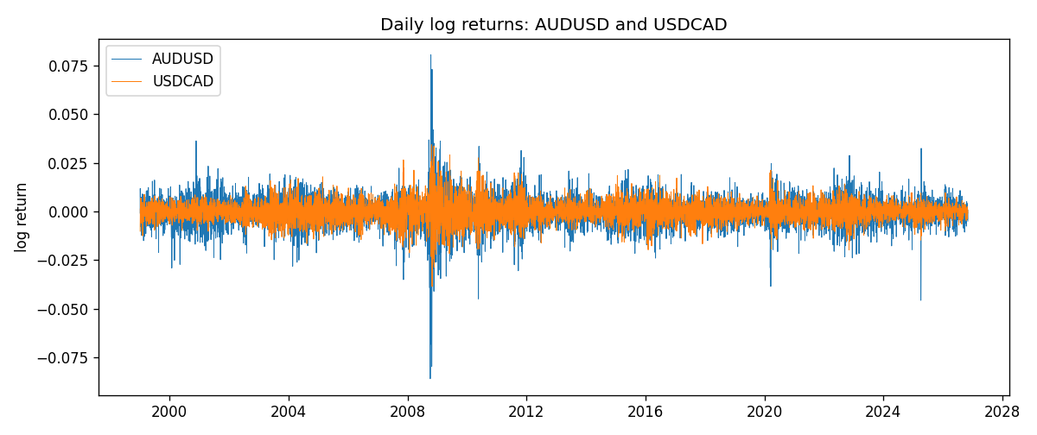
EWMA rho path with Pearson r reference
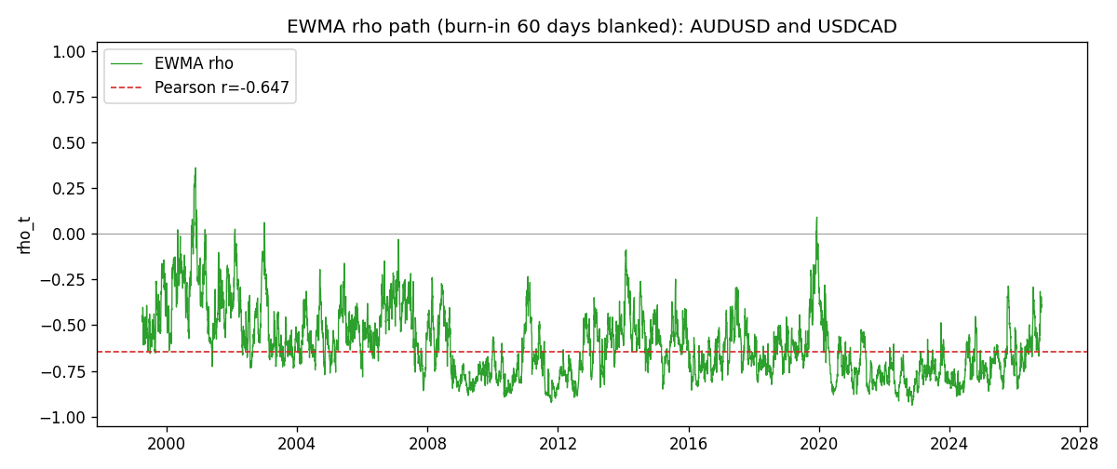

Data report
Every matched row that entered the EWMA recursion is stored in the sibling Excel workbook named AUDUSD-USDCAD_EWMA_D1.xlsx. That file is the complete data archive for redrawing charts. Embedding all rows as a Word table is impractical at this length; the Word file holds the column list, column summaries, and the first and last 15 matched rows.
Columns: time, AUDUSD_open, USDCAD_open, AUDUSD_high, USDCAD_high, AUDUSD_low, USDCAD_low, AUDUSD_close, USDCAD_close, AUDUSD_tick_volume, USDCAD_tick_volume, AUDUSD_spread, USDCAD_spread, AUDUSD_real_volume, USDCAD_real_volume, AUDUSD_log_return, USDCAD_log_return, AUDUSD_x_demeaned, USDCAD_y_demeaned, c_t, v_x, v_y, rho_t
Column summaries (matched calculation rows)
column | count | mean | std | min | 25% | 50% | 75% | max
AUDUSD_open | 7204 | 0.75193151 | 0.13526075 | 0.4785 | 0.6610425 | 0.731405 | 0.8086175 | 1.10284
USDCAD_open | 7204 | 1.2670146 | 0.16899756 | 0.9168 | 1.118975 | 1.298545 | 1.372225 | 1.6183
AUDUSD_high | 7204 | 0.7559812 | 0.13582551 | 0.4878 | 0.6647 | 0.734785 | 0.81467 | 1.10795
USDCAD_high | 7204 | 1.2719163 | 0.16895637 | 0.9336 | 1.123375 | 1.30394 | 1.3767575 | 1.619
AUDUSD_low | 7204 | 0.74787477 | 0.13457623 | 0.4775 | 0.6577 | 0.727495 | 0.8042 | 1.0975
USDCAD_low | 7204 | 1.2624553 | 0.16903522 | 0.9056 | 1.11435 | 1.293585 | 1.3678925 | 1.6102
AUDUSD_close | 7204 | 0.75197934 | 0.13524694 | 0.4786 | 0.6611975 | 0.731695 | 0.808875 | 1.10169
USDCAD_close | 7204 | 1.2670334 | 0.16897258 | 0.916 | 1.11848 | 1.298615 | 1.372515 | 1.6137
AUDUSD_tick_volume | 7204 | 77316.143 | 138115.43 | 109 | 5421.75 | 43310.5 | 71296.75 | 1234623
USDCAD_tick_volume | 7204 | 80846.476 | 147183.52 | 56 | 5511.25 | 40857 | 71531.75 | 1410818
AUDUSD_spread | 7204 | 30.823709 | 16.885829 | 0 | 13 | 30 | 50 | 50
USDCAD_spread | 7204 | 23.505275 | 18.28107 | 0 | 9 | 17 | 40 | 60
AUDUSD_real_volume | 7204 | 5.2399076e+09 | 1.2535442e+11 | 0 | 0 | 0 | 0 | 3.811512e+12
USDCAD_real_volume | 7204 | 1.8332738e+10 | 9.6584767e+10 | 0 | 0 | 0 | 0 | 2.5751613e+12
AUDUSD_log_return | 7204 | 2.007e-05 | 0.0075444 | -0.08602525 | -0.00386183 | 0.00027895 | 0.00414528 | 0.0806166
USDCAD_log_return | 7204 | -1.21e-05 | 0.00514438 | -0.03859748 | -0.00283637 | 4.97e-05 | 0.00272781 | 0.03436319
AUDUSD_x_demeaned | 7204 | -0 | 0.0075444 | -0.08604533 | -0.00388191 | 0.00025887 | 0.00412521 | 0.08059652
USDCAD_y_demeaned | 7204 | 0 | 0.00514438 | -0.03858538 | -0.00282427 | 6.18e-05 | 0.00273991 | 0.03437529
c_t | 7204 | -2.511e-05 | 4.203e-05 | -0.00057343 | -2.533e-05 | -1.555e-05 | -9.12e-06 | 9.38e-06
v_x | 7204 | 5.688e-05 | 0.00010018 | 4e-08 | 2.615e-05 | 3.685e-05 | 5.876e-05 | 0.00173307
v_y | 7204 | 2.645e-05 | 3.12e-05 | 3.69e-06 | 1.173e-05 | 1.803e-05 | 2.906e-05 | 0.00040856
rho_t | 7204 | -0.60027035 | 0.18934663 | -0.93777133 | -0.74668009 | -0.62346801 | -0.49345453 | 1
First 15 matched rows (selected columns)
time | AUDUSD_close | USDCAD_close | AUDUSD_log_return | USDCAD_log_return | AUDUSD_x_demeaned | USDCAD_y_demeaned | c_t | v_x | v_y | rho_t
1999-01-05 | 0.6215 | 1.5123 | -0.00080418179 | -0.010131666 | -0.00082425387 | -0.010119566 | 5.0046547e-07 | 4.0763666e-08 | 6.1443366e-06 | 1
1999-01-06 | 0.6289 | 1.5118 | 0.011836351 | -0.0003306769 | 0.011816279 | -0.00031857695 | 2.445739e-07 | 8.4157841e-06 | 5.7817658e-06 | 0.035061667
1999-01-07 | 0.6345 | 1.5141 | 0.0088650256 | 0.0015202092 | 0.0088449535 | 0.0015323091 | 1.0430916e-06 | 1.2604829e-05 | 5.5757382e-06 | 0.12442361
1999-01-08 | 0.6347 | 1.511 | 0.00031515916 | -0.0020495197 | 0.00029508708 | -0.0020374198 | 9.4443316e-07 | 1.1853764e-05 | 5.4902586e-06 | 0.11707029
1999-01-11 | 0.6393 | 1.5057 | 0.0072213815 | -0.0035137769 | 0.0072013094 | -0.003501677 | -6.252324e-07 | 1.425407e-05 | 5.8965476e-06 | -0.068198234
1999-01-12 | 0.6362 | 1.5157 | -0.0048608485 | 0.0066194721 | -0.0048809205 | 0.0066315721 | -2.529809e-06 | 1.4828229e-05 | 8.1814196e-06 | -0.22968295
1999-01-13 | 0.6312 | 1.5226 | -0.0078902098 | 0.0045420214 | -0.0079102819 | 0.0045541214 | -4.5394835e-06 | 1.7692888e-05 | 8.9349358e-06 | -0.36104502
1999-01-14 | 0.6295 | 1.5332 | -0.002696916 | 0.0069376546 | -0.0027169881 | 0.0069497546 | -5.4000585e-06 | 1.7074237e-05 | 1.1296785e-05 | -0.38882161
1999-01-15 | 0.634 | 1.5245 | 0.007123101 | -0.0056905671 | 0.0071030289 | -0.0056784671 | -7.496114e-06 | 1.9076964e-05 | 1.2553677e-05 | -0.48439101
1999-01-18 | 0.6346 | 1.526 | 0.00094592471 | 0.00098344542 | 0.00092585264 | 0.00099554536 | -6.9910434e-06 | 1.7983778e-05 | 1.1859923e-05 | -0.47869688
1999-01-19 | 0.6392 | 1.5302 | 0.0072225153 | 0.002748513 | 0.0072024432 | 0.0027606129 | -5.3785914e-06 | 2.0017263e-05 | 1.1605587e-05 | -0.35288456
1999-01-20 | 0.64 | 1.5211 | 0.0012507819 | -0.0059646885 | 0.0012307098 | -0.0059525885 | -5.4954304e-06 | 1.8907106e-05 | 1.303525e-05 | -0.35004953
1999-01-21 | 0.6405 | 1.5146 | 0.00078094498 | -0.0042823796 | 0.00076087291 | -0.0042702797 | -5.360653e-06 | 1.7807415e-05 | 1.3347253e-05 | -0.34771331
1999-01-22 | 0.6327 | 1.5184 | -0.012252745 | 0.0025057712 | -0.012272817 | 0.0025178711 | -6.8930962e-06 | 2.5776293e-05 | 1.2926798e-05 | -0.37762317
1999-01-25 | 0.6302 | 1.5197 | -0.0039591468 | 0.00085579808 | -0.0039792189 | 0.00086789803 | -6.6867238e-06 | 2.5179766e-05 | 1.2196385e-05 | -0.38156803
Last 15 matched rows (selected columns)
time | AUDUSD_close | USDCAD_close | AUDUSD_log_return | USDCAD_log_return | AUDUSD_x_demeaned | USDCAD_y_demeaned | c_t | v_x | v_y | rho_t
2026-10-13 | 0.69821 | 1.4214 | 0.0035007712 | -0.0046395653 | 0.0034806991 | -0.0046274653 | -5.5606804e-06 | 1.413052e-05 | 7.2162444e-06 | -0.55067232
2026-10-14 | 0.69715 | 1.42356 | -0.0015193215 | 0.0015184751 | -0.0015393935 | 0.001530575 | -5.3684091e-06 | 1.3424873e-05 | 6.9238293e-06 | -0.55682321
2026-10-15 | 0.69191 | 1.41843 | -0.0075447063 | -0.0036101503 | -0.0075647784 | -0.0035980504 | -3.4131973e-06 | 1.6052933e-05 | 7.2851575e-06 | -0.31562015
2026-10-16 | 0.69426 | 1.41357 | 0.0033906408 | -0.0034322068 | 0.0033705687 | -0.0034201068 | -3.9000677e-06 | 1.5771401e-05 | 7.5498759e-06 | -0.35741034
2026-10-19 | 0.6978 | 1.41091 | 0.0050859986 | -0.0018835331 | 0.0050659266 | -0.0018714332 | -4.2348963e-06 | 1.6364934e-05 | 7.3070191e-06 | -0.38727149
2026-10-20 | 0.70022 | 1.40569 | 0.0034620426 | -0.0037066008 | 0.0034419706 | -0.0036945009 | -4.7437843e-06 | 1.6093867e-05 | 7.6875582e-06 | -0.42648181
2026-10-21 | 0.70275 | 1.4045 | 0.0036066384 | -0.00084691787 | 0.0035865663 | -0.00083481793 | -4.638805e-06 | 1.5900043e-05 | 7.2681199e-06 | -0.43151503
2026-10-22 | 0.70186 | 1.40081 | -0.0012672558 | -0.0026307268 | -0.0012873279 | -0.0026186269 | -4.1582148e-06 | 1.5045473e-05 | 7.2434651e-06 | -0.39831881
2026-10-23 | 0.70353 | 1.40085 | 0.0023765656 | 2.85545e-05 | 0.0023564936 | 4.0654446e-05 | -3.9029738e-06 | 1.4475928e-05 | 6.8089564e-06 | -0.39312635
2026-10-26 | 0.70128 | 1.40093 | -0.0032032829 | 5.7106554e-05 | -0.003223355 | 6.92065e-05 | -3.68218e-06 | 1.4230774e-05 | 6.4007064e-06 | -0.38581296
2026-10-27 | 0.70245 | 1.40449 | 0.0016669876 | 0.0025379458 | 0.0016469156 | 0.0025500457 | -3.2092666e-06 | 1.3539667e-05 | 6.406828e-06 | -0.34457223
2026-10-28 | 0.70533 | 1.39911 | 0.0040915541 | -0.0038379274 | 0.004071482 | -0.0038258274 | -3.9513179e-06 | 1.3721905e-05 | 6.9006356e-06 | -0.40606001
2026-10-29 | 0.70245 | 1.39895 | -0.0040915541 | -0.00011436495 | -0.0041116262 | -0.00010226501 | -3.6890103e-06 | 1.3912919e-05 | 6.487225e-06 | -0.38830346
2026-10-30 | 0.70316 | 1.39751 | 0.0010102376 | -0.0010298736 | 0.00099016556 | -0.0010177736 | -3.5281355e-06 | 1.3136969e-05 | 6.1601433e-06 | -0.39219519
2026-11-02 | 0.69971 | 1.39837 | -0.0049184984 | 0.00061519094 | -0.0049385705 | 0.00062729089 | -3.5023226e-06 | 1.381212e-05 | 5.8141443e-06 | -0.39082566

